**1st Lab - Basic LAN Design with Router, Switch & Hub**

**Software Used:**

* Cisco Packet Tracer

**Topology:**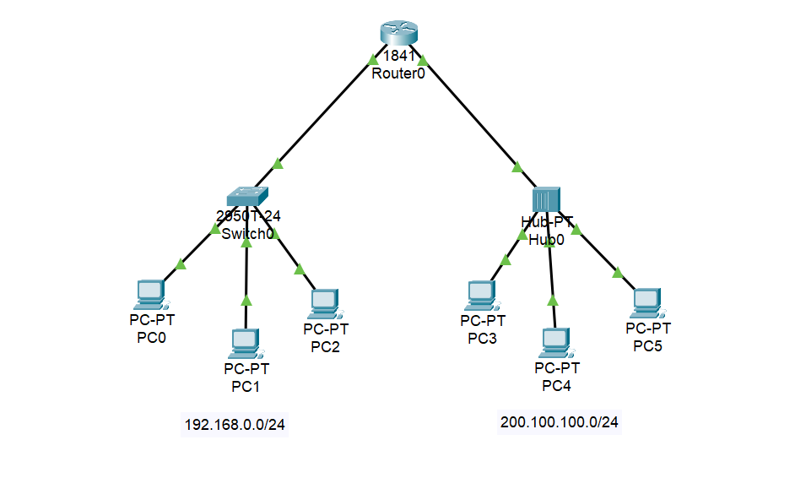

1. **Network Topology Overview:**

* **Router:** Central device connecting two separate networks.
* **Switch:** Connected to Router's FastEthernet0/0 interface.
* **Hub:** Connected to Router's FastEthernet0/1 interface.
* **PCs:** Connected to both Switch and Hub, each assigned appropriate IP addresses.

1. **Protocols & Systems:**

* **ICMP (Internet Control Message Protocol):**  
  Used for testing network connectivity (e.g., using ping command)
* **IOS (Internetwork Operating System):**  
  Cisco routers/switches use this OS for CLI-based configuration
* **CLI (Command Line Interface):** Interface used to configure Cisco devices.

1. **PC Configuration:**
2. **PCs Connected to Switch:**

Assign IP addresses in the 192.168.0.0/24 network.

Example:

* + - IP Address: 192.168.0.2
    - Subnet Mask: 255.255.255.0
    - Default Gateway: 192.168.0.1

1. **PCs Connected to Hub:**

Assign IP addresses in the 200.100.100.0/24 network.

Example:

* + - IP Address: 200.100.100.1
    - Subnet Mask: 255.255.255.0
    - Default Gateway: 200.100.100.254

1. **Command Modes:**

* **User EXEC Mode:** Router>
* **Privileged EXEC Mode:** Router#
* **Global Configuration Mode:** Router(config)#
* **Interface Configuration Mode:** Router(config-if)#

1. **Router Configuration Steps (CLI):**

Continue with configuration dialog? [yes/no]: no

Router> enable

Router#

Router# configure terminal

Router(config)#

Router(config)# interface fastethernet 0/0

Router(config-if)# ip address 192.168.0.1 255.255.255.0

Router(config-if)# no shutdown

Router(config-if)# exit

Router(config)# interface fastethernet 0/1

Router(config-if)# ip address 200.100.100.254 255.255.255.0

Router(config-if)# no shutdown

Router(config-if)# exit

1. **Ping Test (Check Connectivity from Command Prompt)**
   * ping 192.168.0.1
   * ping 200.100.100.254